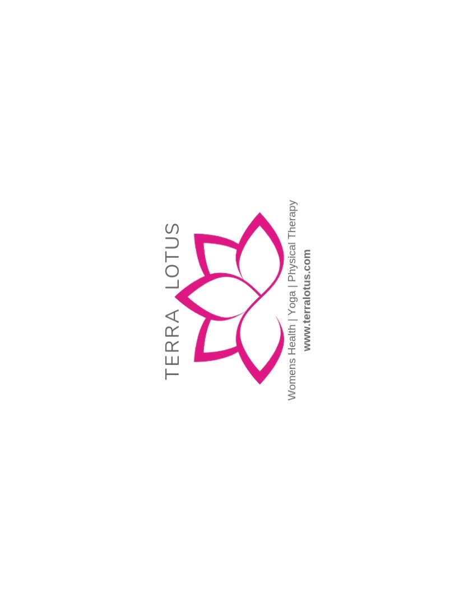

Bladder Irritants

Certain foods and beverages irritate the bladder and can cause muscle dysfunction in some people. Not all people are irritated by the same substances.

The most common foods/beverages:
Coffee
Tea
Carbonated beverages- caffeine free and water, included
Acidic fruits- grapefruit, orange, lemon and limes- along with juices
Spicy foods
Tomato based products
Chocolate

This list is not exclusive, some people are sensitive to bananas, nuts, alcohol, dairy and berries

Some food items that can be calming to the bladder may include:
Water
Pears
Bananas
Green beans
Winter squash
Potatoes

